OCR A-LEVEL COMPUTER SCIENCE NEA
  - H446-03

Name: Jack Oliver Hughes
Candidate Number: <INSERT CANDIDATE NUMBER>
North Bromsgrove Sixth Form: <INSERT CENTRE NUMBER>
Title of Project: Formula 1 Race Engineer Simulator

PROJECT CONTENTS

Contents
Contents 2
Analysis 3
Project Introduction 3
Stakeholders 4
Interview with stakeholder 6
Essential Ideas 7
Limitations 9
Solution Requirements 11
Existing designs 12
Race engineering software 12
Data generation software 16
Using computation methods 21
Success Criteria 22
Design 26
Top-Down Structure Diagram 26
Startup Menu 27
Confidence System 28
Generation of race data 29
Software versions 30
References 31

Analysis

Project Introduction
Race engineering is the act of maximizing a car’s performance by interpreting communication from the driver, real time data and coordinating with team members such as mechanics. My project will try to replicate that, allowing users to look at simulated race data, analyse it and communicate with a driver to give them feedback and maximise pace around a track.
Currently, there is a gap in the market for race simulation. There is a lot of software out there that can give an in-depth analysis of race data, some use machine learning, some have advanced graphical user interfaces, but all of them require a separate input of data, creating inconvenience for those who are seeking quick analysis of data.
For example, if a motorsports team wants to train their race engineers, they have 2 options: either let them shadow an experienced engineer on race days, often making the senior engineer’s job more difficult and costing them in terms of competition, or they could bring their car out on non-race days and have the engineer practice there, which is very expensive because they have to rent the track, buy fuel, buy new tyres, etc.
However, my program will attempt to solve this problem by allowing engineers to practice their race engineering in a controlled, cost-effective environment by generating the race data artificially. This way, my project will offer an all-in-one solution without any need for external input/output.
My project could also be used for educational purposes, such as F1 in schools or engineering workshops. All of these points will be explained deeper into the analysis section (below).

Stakeholders
My project is niche; however, it may appeal to a fairly wide range of people. There is a wide range of experience, age, purpose and use-case amongst my stakeholders and as such I will explain what each category is and what they would want from the project.
Therefore, my stakeholders are as follows:
Stakeholder category | Description | How my product will benefit them
Motorsports fans (Formula 1 in particular) | Fans of F1 will enjoy and use my project as it gives them an alternative view of motorsports. My project is appropriate to them due to the fact that they will be interested in how some factors affect others and may use my program to investigate min-maxing the simulation stats.  They will appreciate a well-designed user interface that is easy to interact with and is self-explanatory, requiring little engineering experience to learn the software and how things work. They may also appreciate a startup menu where they can change the difficulty, letting them progress more naturally. | They will be able to get a behind the scenes view into how their favourite sport will work. They are also likely to learn a bit about the mechanics of Formula 1 and may even pursue a career in the industry as a result.
People with an interest in mechanics | This group will appreciate my project because they can use their skills and apply it to my simulation. Applying the knowledge and seeing real results happening in real time will be very satisfying for them.  They will appreciate a wide range of parameters that are available to change as they will be able to apply their knowledge more often and the user experience will be a lot more satisfying for them. | They will be able to apply their knowledge of mechanics to a real product, reinforcing their knowledge and helping them learn in a fun, interactive and engaging way.
Motorsport teams looking to train their race engineers | Motorsport teams will appreciate the all-in-one aspect of my project as all they have to do is run the program and then their race engineers can practice. Usually, they would have to connect a race engineer software to either a real car or use telemetry data from a game/simulator such as Assetto Corsa, but my project is an all-in-one solution.  Motorsports teams will appreciate having everything ran in once place / program. On top of this, they will want to be able to analyse a large range of data points (e.g. track temperature, weather, tyre data, engine data, etc.), often simultaneously: either plotted driver-to-driver or category-to-category to simulate real racing conditions as close to real life as possible. | The teams will be able to train their engineers in a semi-realistic environment at a very low cost, giving their engineers experience and allowing the team to perform better on race days, leading to them winning more often.
Aston University: F1 in schools | Aston University offers an F1 in schools program to try and get young people into engineering fields. They could benefit from my project due to it revealing some of the behind-the-scenes action that happens at F1 races, making the student’s experience more interactive and engaging.  Similar to motorsports fans, they will appreciate a well-built UI that is easy to introduce younger people to, perhaps including tooltips on the graphs and buttons. | My program can be used as a learning aid in the workshops, making their programme a lot stronger and enticing more young people to pursue a career in the industry.

Interview with stakeholder
To find out my stakeholder’s needs in a bit more depth, I will offer an interview to a Formula 1 fan that I know: Alfie. Below are a list of questions and responses that I have found from my interviews.

Interview conducted 03/03/26:
- What makes a simulation good?
  - What would make a racing simulation enjoyable for you?
    - Tyre degradation model
    - Aerodynamic model
  - What are some of the core features you would like to see?
    - Setup manager (e.g. wing angles)
    - Pit stop functionality
  - Would you rather an arcade or realistic-style simulation?
    - Realistic style
  - Do you prefer efficiency or depth of simulation?
    - Depth of simulation
- What would you want to see from the UI?
  - How would you like data to be shown?
    - Graphs
    - Tables (e.g. leaderboard)
    - Colour coded
    - Track map
      - Circular map + Corner by corner map
  - Which menus would you like to see?
    - Ability to toggle menus
    - Race statistics
    - Pit stop menu
    - Leaderboard
    - Strategy
  - Should it look like a race engineer’s workstation or an easy-to-use program?
    - Race engineer’s workstation
- What would you like to see from the engineer-driver interactions?
  - The range of communication options will have to quite narrow due to time limitations. Are there any specific options that you would like to see implemented?
    - Pit stops at a specific point
      - Change tyres and wing
    - Strategy with driver
  - Would you prefer to select your options using buttons or menus?
    - Drop down menus
  - What would you want to see from a confidence system?
    - Affects likelihood of crashing
    - Engineer decisions affect it

Essential Ideas
Before looking at other designs, I will map out a wireframe of what I want my final design to look like. As previously stated in the project introduction section, I want my project to have 3 main functions: generate race data, display it on a suitable user interface and allow communication between the engineer and the driver. In the table below, I will list sub-features that I think should be included, along with a justification of why it will be implemented into my final design.
Initial idea | Description | Justification
Tyre Models | - Tyre temperatures, both carcass and surface.  - Temperatures change whilst braking, accelerating and turning.  - Tyre wear (modelling things such as graining, flat-spotting, temperature-based wear and tyre-type based wear) | Detailed tyre models will provide the user with a product that is less likely to break mid-session whilst also providing enough detail for experienced fans/engineers in the form of high-volume, high-quality race data.
Track Models | - Localised track temperature (hot in some places, cold in others)  - Tyre marbles on the track, adds detail into overtaking  - Track water levels from raining (gets wet fast, takes a while to dry) | Various dynamic track conditions will mean that the user experience is more thrilling for users, captivating the younger/less experienced audience.
Storing data in a SQL file | - Store data in SQL tables (1 table for each car, 1 for the track conditions) | Storing data using SQL will allow easy read/write capabilities, with the user being able to search records by a certain data type (e.g. search for only surface temperatures) and quickly output it to a graph
Graphs and Charts | - Display information and data visually, looks more appealing than lists  - Shows changes over time, allows the user to make decisions based off trends  - Can be used to compare 2 types of data, therefore it can be used to get a deep analysis of the race situation  - Can be used to show most race data, reducing my workload as a sole developer as I don’t have to produce too many different mediums to display data | Graphs and charts will appeal to all of my stakeholders: the less experienced users will find the graphs visually appealing, therefore becoming more interested in the project and wanting to learn more about racing and the more experienced / professional users will be able to use it as an analysis tool to find the best strategies for the race, allowing them to use their skills that they have learnt to try and win, giving them enjoyment when they finally beat their opponent.
Leaderboard | - Colour coded data makes the data easy and intuitive to view at a glance whilst simultaneously making my project look better and more professional  - Can show a lot of data in one easy to use place | The intuitive aspect of this will appeal to the less experienced and younger audience as they will feel that the product is simple and they don’t have to have training on this program in order to use it. The experienced users will also appreciate it being easy to view at a glance because they will likely be looking at a myriad of different data types so knowing that they can easily find what they want will provide satisfaction.
Communication System | - Gives the user a way to translate their analysis into improving the driver’s pace  - The user will be able to select from a wide range of options what to tell the driver to do  - Change their pace  - Recommend settings changes  - Recommend short/long term strategies  - Good decisions positively affect confidence (below) | Having analysed the driver’s data, the communication system will allow the engineer (user) to use what they know and attempt to make strategy calls. The satisfaction that will come from good decisions paying off will be immense, enticing the younger / less experienced users to learn more about motorsports. This matches up well with the “F1 in schools” programme at Aston University, as they try and get young people into engineering using motorsports as a medium – my project will accentuate this and heavily compliment their goals.
Driver Confidence System | - Race actions/decisions affect confidence dynamically  - Good engineer decisions that aren’t too controlling and are sent with a good frequency increase the driver’s confidence level  - Higher driver confidence results in things such as faster race pace, more overtakes and a lower chance of incidents and vice versa  - Every action that the engineer takes will have a greater effect | This system’s implementation will greatly benefit all of the end users. The experienced users can implement their real engineering methods, and it will have a greater effect on the driver’s pace and other stats. All in all, their good decisions will compound through both confidence and race pace, leading to a satisfying user experience. It will also benefit less experienced users because the driver on the other end will feel more human, leading to a nicer experience for them too. Overall, it just greatly increases the depth of the simulation and benefits everyone.

Limitations
Being a sole developer and having little time to finish my design, I will have to overcome a range of different limitations. Below is a list of them and how I will attempt to overcome them:
Limitation | Description | Actions to Take | Justification
Time | The deadline for the project is 15/05/2027, giving me about 16 months in total to go from an idea to a final design and report. | - To ensure that I stay on track, I will define my scope and features at the start  - I will ensure that I am meeting all deadlines set by my teachers. | There is a final deadline for the 15/05/2027.
Expertise | Although my Python skills are quite well developed, I do not have the expertise of a fully trained software developer. Likewise, I have a fair knowledge of Formula 1, but my knowledge is not as deep as an aerospace or mechanical engineer. | - The simulation will not be built to be completely scientifically accurate.  - It will model the ideas that I have listed using things like random numbers.  - Formulae will be basic and easier to implement than genuine engineering formulae.  - Not every data point about a Formula 1 car will be modelled, only ones that I deem necessary for the sake of simulation | I do not hold any formal computer science certificates apart from GCSE Computer Science.
Complexity | This project will involve a large volume of moving parts that all need to interlace correctly to produce a good result, on top of this there is lot of mathematical formulae that will need to be coded in to fully simulate things such as tyre temperature and track conditions. | - I will define scope at the start  - I will keep features simple and easy to implement whilst simultaneously keeping simulation accuracy high  - Only certain conditions / features will be modelled | There are a lot of different parts that have to work in sync. (e.g. data generation, analysis, communication).
Resources | Many programmers today make great use (often overuse) of artificial intelligence / code generation tools.  Also going to be a local project with no network capability. | - I won’t use AI to write code  - I will use a range of planning strategies to plan out my code such as flowcharts and pseudocode.  - Product will have to be shipped fully working as it is harder to update (no network capabilities and even if there was, I would have to implement an installer package which I cannot do with my level of expertise) | The product will have no networking capabilities and I am unable to use AI and advanced coding features.
Stakeholders | The range of stakeholders for my project is fairly large: one user could be a 15-year-old racing fan, another could be a seasoned mechanical engineer. | - I will make the user interface readable and easy to use for all stakeholders, perhaps by adding tooltips and ensuring everything is spaced enough for readability  - I will make the simulation depth deep enough for the experienced users whilst explaining it in depth for users who won’t understand | The is a large range of stakeholders of which I will have to accommodate to.
Real Time / Concurrency | The simulation cannot just generate results once a button is pressed. The data and analysis have to run as the simulation progresses, adding another layer of complexity to the project. | - Ensure all parts are able to run in harmony  - Allow the user to interact with the simulation whilst it is running | I will have to make the program run concurrently and maintain interactivity.

Solution Requirements
Below is a list of requirements that must be present on the end user’s device in order to run the program properly:
Libraries | These libraries should be built into the newer versions of python. If they are not, the user could attempt to run the command:  pip install <package name>  in the python shell.  Tkinter for GUI’s  Matplotlib for graphs to display race data  Threading for parallel processes
Software versions | As my project is offline, there is no need to future-proof my code for library updates. Most of the libraries used should be able to run on any computer and the versions of each software that I will use is listed in the software versions section.
Hardware and software requirements | A lot of data will be displayed on the user’s display, so it is recommended that they have a good enough resolution monitor. The device should run at least Windows 10, and it must be updated to its newest version. If the program is to run on a Mac or Linux system, whilst I cannot confirm if it will work (due to my time limitation), Mac OS should be on at least MacOS 10.9. There are too many Linux distributions such that I am unable to provide a clear answer for what software version the user should be running.  Minimum RAM: 4GB – needed to store and process race data  Minimum Storage: 10GB due to storing lots of race data long-term  Minimum Processor Clock Speed: 1.5GHz – enough to run all necessary calculations in real time  Recommended Cores: 4 Cores – preferred for ease of concurrency

Existing designs

Race engineering software
Whilst most of the actual race engineer software is stuck behind very large paywalls, there does exist a multitude of software that links up to racing games (e.g. Assetto Corsa / F1 franchise, as stated in my introduction). Below are some examples, and in addition I will state the features from each that I will use in my design:

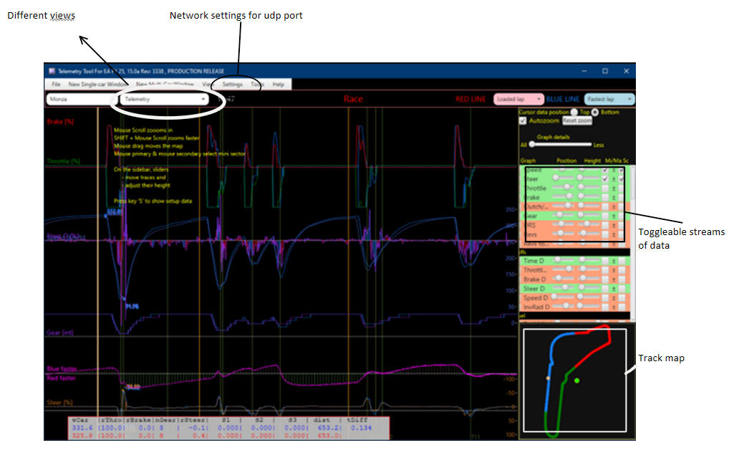
Telemetry Tool V.15
(Rein, 2011)
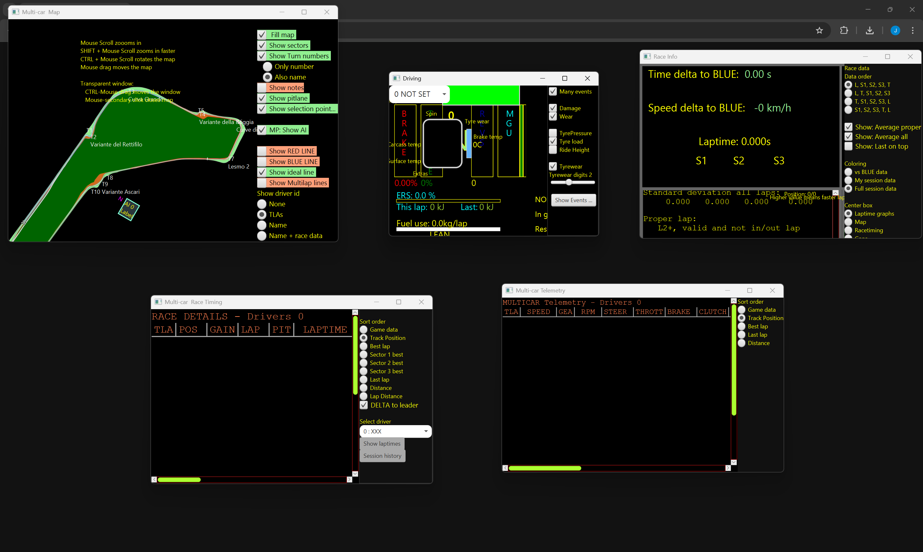
Telemetry tool is a software program that utilises the UDP telemetry port to get input data from the driver. It then outputs the data into clean, readable graphs and tables with multiple different views (e.g. track map, telemetry graphs, comparison view). Another part of the UI I like is being able to bring up multiple different windows with different data, providing a dynamic and easy to implement user experience. The UI, whilst having multiple different elements and being easy to navigate, is quite hard to understand, with certain data points having abbreviated names with little to no explanation of what they do/represent: relying on the user’s prior knowledge to know what to do. Another thing that I dislike about the UI is the consistency across categories: each tab has a different font and slightly different styles, making it look unprofessional and slightly more difficult to learn.
Looking closer into UI design, all of the controls are situated along one side of the screen, primarily the right-hand side. This could easily be done using the Tkinter grid system, setting the main content and settings to be in column 0 and 1 respectively. On top of this, there is a very low number of text input boxes, a lot of commands are done using key binds, check buttons or radial buttons. This helps keep the UI simple and easy to implement which is beneficial for my time limitations and satisfying stakeholders.
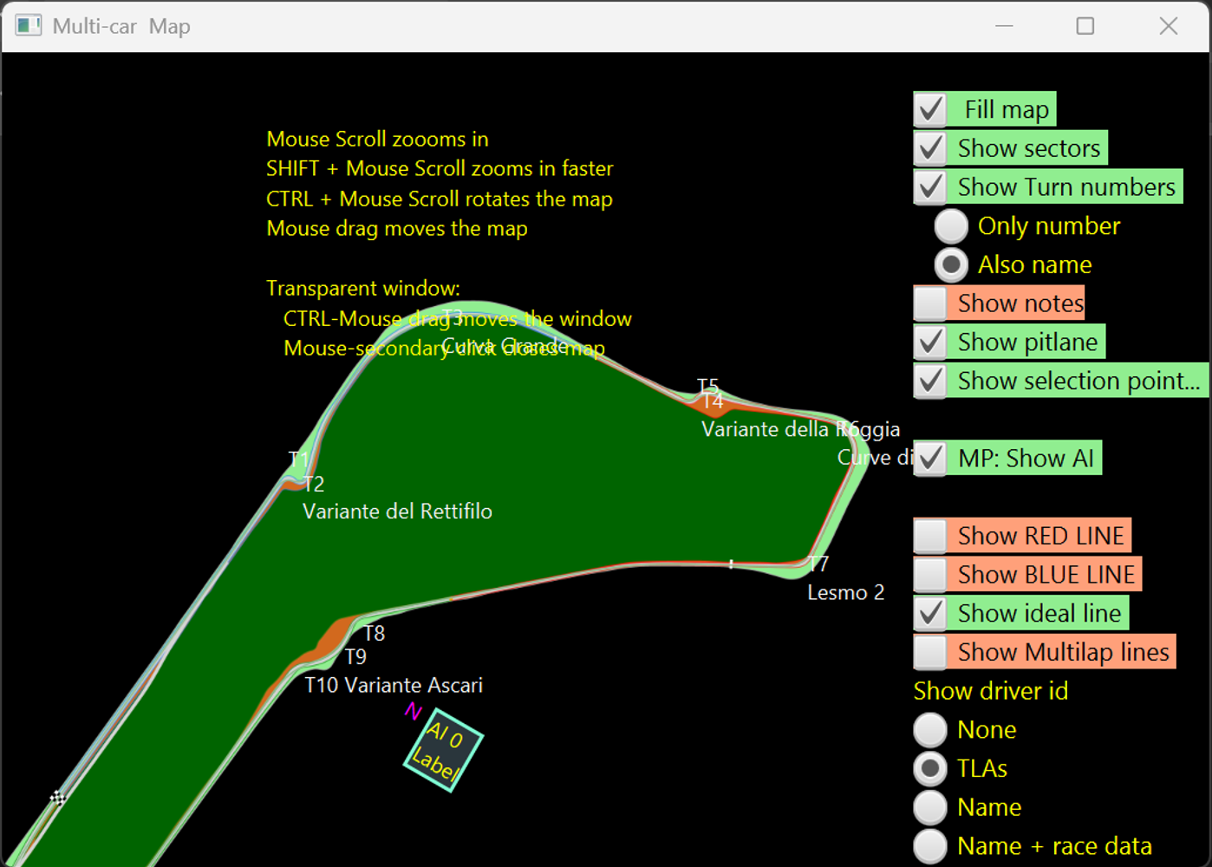
Knowing this, the following table will outline the parts of this program that I will include in my design:
Feature | Justification
Clean, readable UI | Benefits younger stakeholders and casual fans due to it being easier to look at and use.
Multiple, easily accessible views | Again, benefits younger stakeholders but it also benefits the more experienced engineers as they will be able to see everything easier and will be able to perform better.
Ability to open multiple windows | Gives the user more control over how they want to set up their view. Less experienced users will have less tabs open and vice versa.
Layout of content | Keeps a consistent design profile throughout, making the software easy to learn and navigate (benefits less experienced users primarily).
Simple controls | Simple buttons and key binds create an easy to use and implementable solution for controlling the sim.
Track Map | Looks visually appealing and benefits everyone. Gives the user a good idea of what’s going on straight away.

f1-dash.com
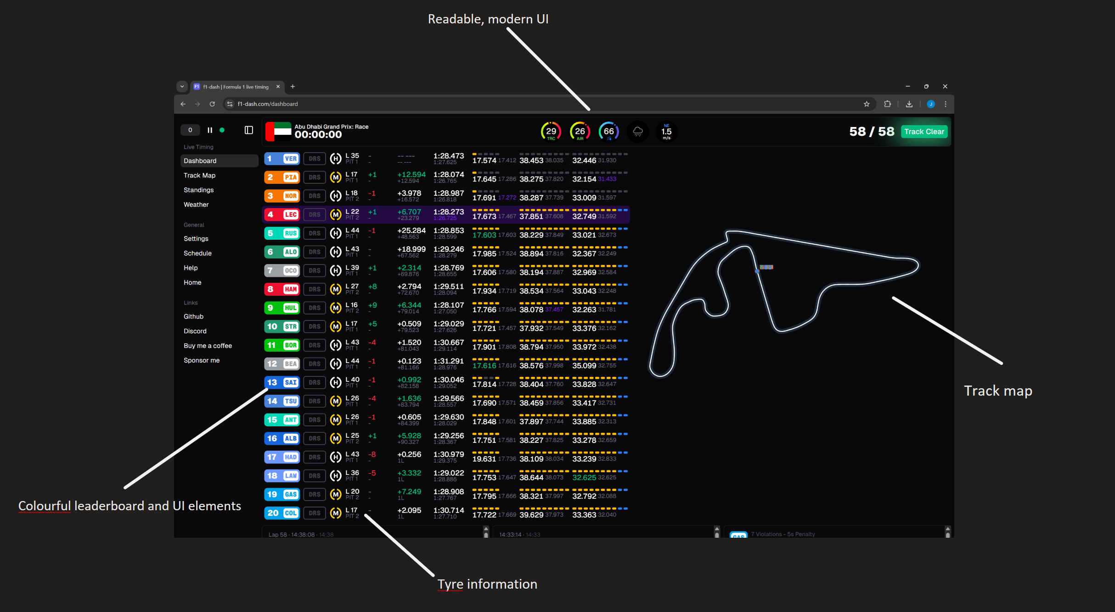
f1-dash.com is a lot less detailed than telemetry tool: however, there are a lot of positives that can be taken away from their design. For example, the graphical user interface is a lot more modern, clean and user friendly, making it more accessible for younger/less knowledgeable fans. Furthermore, a lot of bright colours are used to categorise data, which makes everything easy to use at a glance.
One downside to this design is that, although the data is presented well, there is not a lot of it. Tyre data is very basic with no information to do with temperature and wear, and there is no real telemetry data such as throttle and brake inputs. Given, this is not a website to perform race engineering, I have simply picked out the user interface design points that I want to keep.
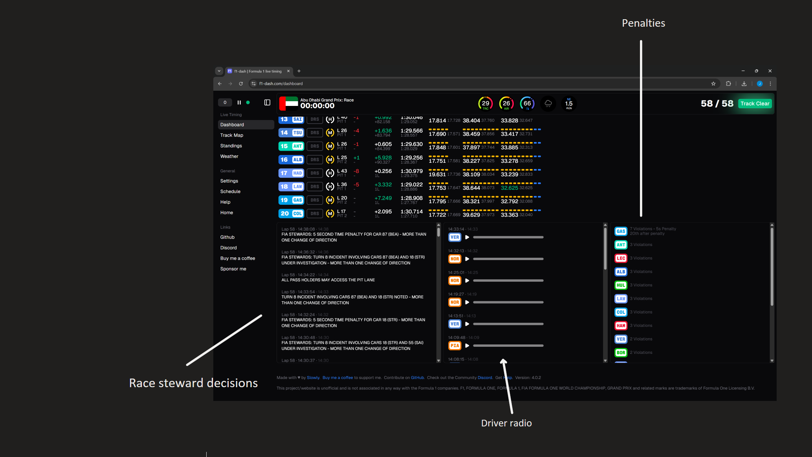
Scrolling further down, I can see a few more great features that I would like to implement. Firstly, there is a clean and easy to read “penalties” section that displays the time penalties that each driver has. This is vital information for a race engineer to know and therefore it should be both included in my design and easy to use. Secondly, there is a steward decisions section where the race engineer can view what the FIA (F1 rules authority) are currently doing. This could tie into the confidence system that I want to build, where regular updates about the steward decisions could cause greater trust in the engineer and instil confidence in the driver’s own ability.
Finally, there is a radio section that I will omit from my design as it has an audio record of all of the driver-engineer communications. My design will have a communication interface, but it will not involve talking freely to the engineer and will be a select-your-option implementation. However, I may take inspiration from the UI elements, as I am going to do with a lot of other elements.
Feature | Justification
Colourful User Interface | More appealing to younger stakeholders. Also allows information to be viewed at a glance (e.g. you look out for your team’s colour instead of scanning the leaderboard) and therefore leads to faster processing of data from the user’s point of view.
Specific information pages (i.e. radio, penalties, leaderboard) | Easy to navigate to each page, benefits all stakeholders as program will be easier to use and therefore race engineering will be more efficient.

Data generation software
The other part of my project consists of generating race data. This is quite a niche program to do solely on its own as there is no market for it currently, so I will have no programs where I can make direct comparisons from. However, lots of racing games generate similar data to mine and so I will choose 2 designs for the features that my data generation component will inherit:

Forza Horizon 5
Forza is a franchise of arcade racing games where the target market tends to be towards those seeking a less realistic but easy to play solution. The game is considered unrealistic by some people, so therefore there will be quite a few features I will discard as I am going for realism, not arcade type simulation.

(TmarTn2, 2021)
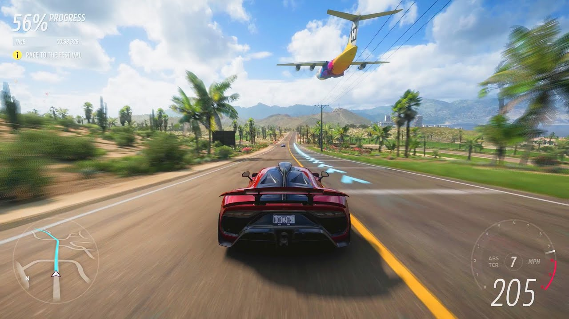
(Microsoft, 2021)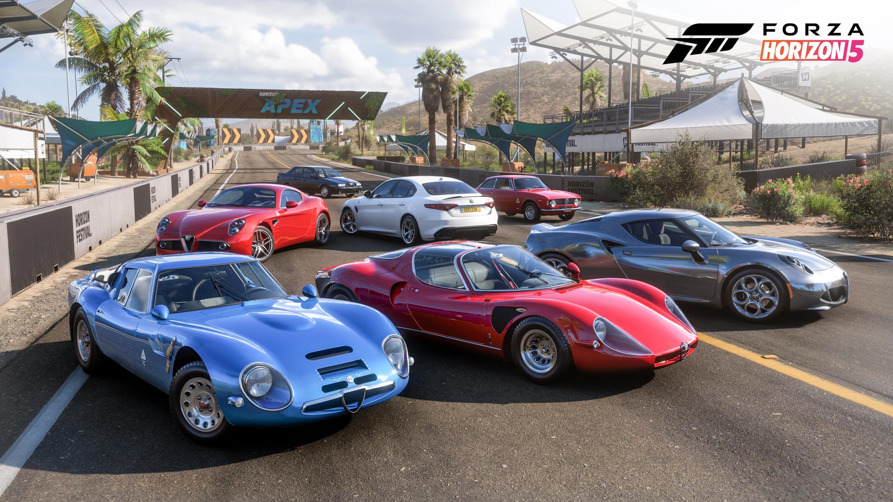
There are a multitude of features above that I can and cannot take into my final design. Microsoft and Playground Games have put a lot of time, money and effort into the graphics, which I do not have the expertise or time to do. They lack extensive/technical race data with there not being enough data for what my high expertise stakeholders would like. The car also cannot be modified whilst driving, which is essential for Formula 1 drivers to control the systems for effective racing.
However, I like their usable UI. Also, the data that they do have is modelled well, some of which being engine RPM, speed, gear, tyre temperatures, slip and fuel.

Feature | Justification
No 3D graphics | Time limitations means that I cannot implement this and my problem has been abstracted to not include it.
Useable clean UI | All parties benefit from this because it will make the program easier to use and their results will be more successful

Assetto Corsa
(Srl, 2014) ((F-Man), 2017)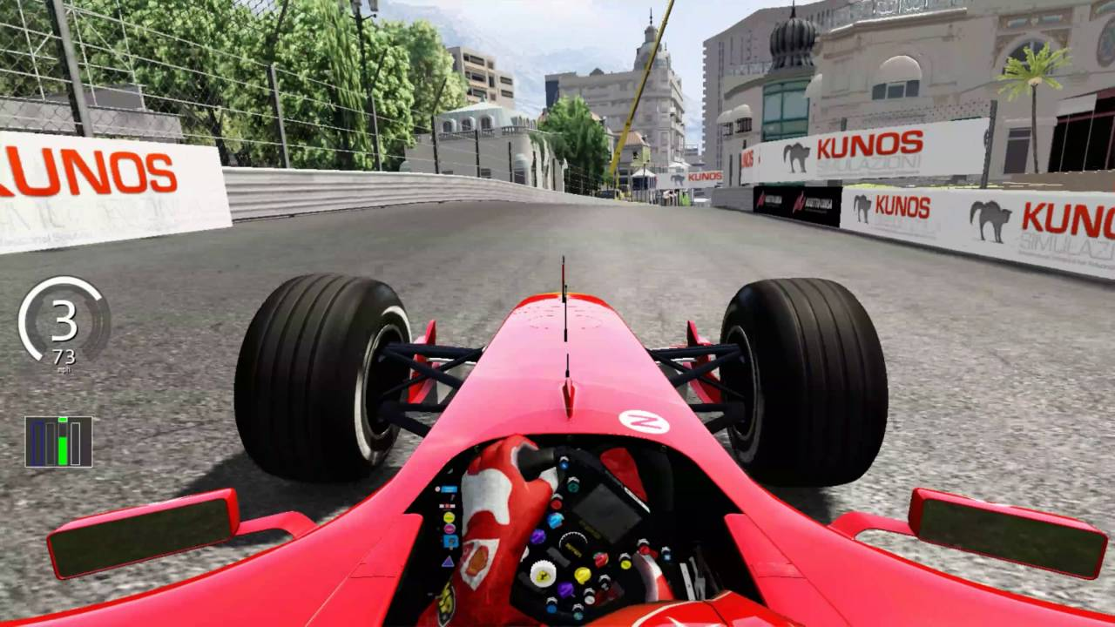
Assetto Corsa is a racing simulator developed by Kunos Simulazioni Srl which is designed to bring realistic race simulation to many classes of cars such as GT, Formula and even road cars. It’s main selling point over competitors is its tyre simulation model, which models both carcass and surface temperatures and slip and wheelspin. It also allows drivers to change a multitude of settings on the go to allow full control over the car such as battery and fuel modes, DRS, engine braking, energy recovery settings and more. It also has a much greater focus on motorsport over Forza, with there being different events such as yellow and blue flags and races are structured with pit stops and full-length race options.
((x4fab), 2024)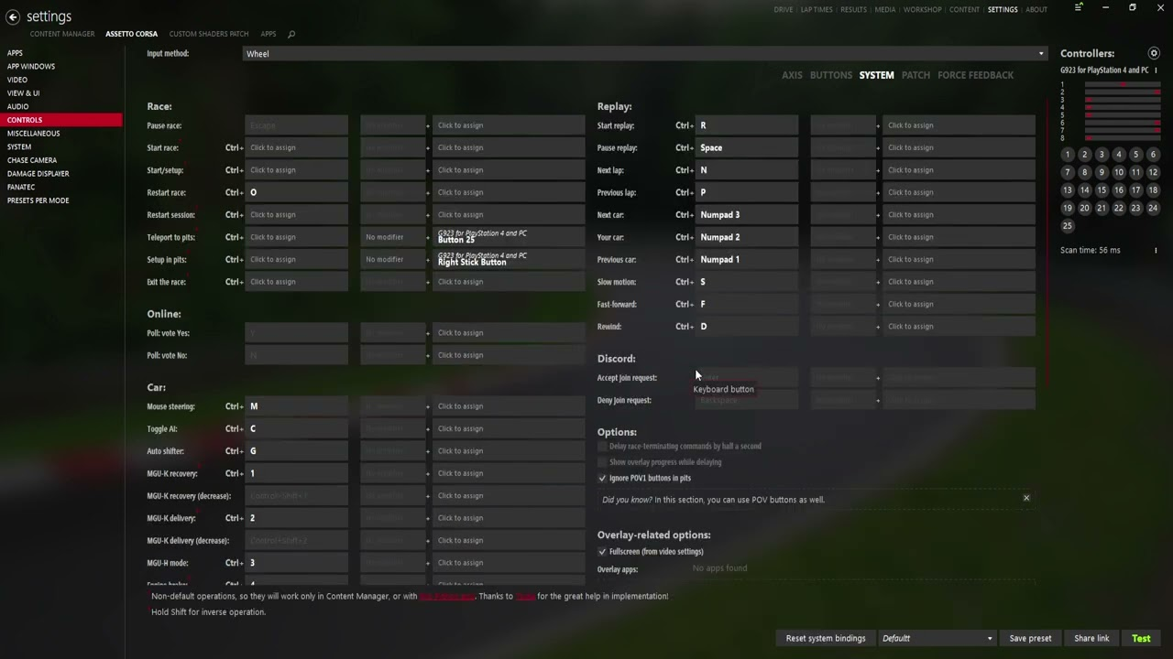
As always with these racing simulations, I am only investigating their design for their data generation aspect. Therefore, I cannot use their 3D graphics part. I also will not go as in-depth as Assetto Corsa due to my limited time and expertise. Due to this, I have gathered that my project’s data generation complexity will lie somewhere between Forza’s and Assetto Corsa’s.
Feature | Justification
Advanced tyre physics | Gives depth to the simulation, satisfying the experience target group due to their technical skill use opportunity
Customisable settings | It will give the user more ways to change the outcome of the race, creating a more satisfying user experience.

Using computation methods
My problem lends itself nicely to a computational approach for a multitude of reasons. Lots of race data will have to be generated and stored in a timely manner, this is simply impractical to do by hand. Lots of data will also have to be presented to the user, therefore using built in libraries such as Matplotlib will be beneficial as it can display graphs in an instant whereas drawing out the graph by hand or using analogue tools would be unnecessary.
The main idea of using a computer for this project is that it automates the behind-the-scenes calculations and lets the user enjoy using the product. Below is a list of my computational methods and my justification behind them: #Come back to after coding
Method | Description | Justification
Abstraction | I will use abstraction to remove unnecessary features from my simulation (e.g. generating extensive simulation data such as gearbox wear, wheel slip and spin and crash physics and creating complicated user interfaces such as driver onboard cameras or pit stop graphics). This is certainly due a computational approach like this due to the sheer scale of the project: in real life there are millions of data points and complicated analysis software. I will recreate a simplified version of these points for my final design. | As said previously in my limitations section, I have a limited amount of time. Therefore, it would be impractical to try and model so many different things in such little time. Abstracting the problem means that I will deliver a finished (although less detailed) project that is going to work seamlessly for the user, giving them great satisfaction when using it.
Thinking Ahead | Being as complex as my program is, I will have to greatly consider the system inputs, outputs and preconditions. For example, my project will be a loop, where race data is generated, then analysed by the user, inputs are sent back to the driver which then changes race data, etc. I will have to carefully plan my subroutines such that the inputs and outputs all connect successfully and provide a seamless user experience. | There are going to be thousands of data points for each car and there are going to be 20 cars on the grid, meaning that the data flow has to be seamless and error free. Hence, I will put a great emphasis on error handling and input validation/sanitation.
Thinking Concurrently | As my program will attempt to simulate three main areas (i.e. generating simulation data, presenting it in an easy-to-use interface and a communication system back to the driver), multiple programs will be running concurrently to provide a seamless user experience. The requirement to think concurrently for this program is necessary as all the functions and procedures are required to be synchronised to make the flow of the race feel natural and as close to a real race engineering experience. | If the software runs all 3 sections simultaneously, the user will not have to spend time trying to get the program to flow smoothly as the computer will do it itself. This will benefit my younger and less experienced stakeholders as they may not know what to do when they first load the program. All in all, thinking concurrently will positively affect program flow and stakeholder satisfaction.

Success Criteria
In order to check that my project satisfies stakeholders and conforms to the project requirements, I will use a success criterion.
Index | Criteria | How I will check this | Justification | Reference (s) | ✅
01 | Well-designed UI | The UI must be colourful, easy to use for all users, clean and readable | Less experienced users in particular will struggle to navigate a poorly designed UI | Existing designs, Stakeholders
02 | Explanation of all controls | Buttons and graphs will have tooltips that tell the user what they do | Having all of the controls explained will reduce confusion amongst less experienced users | Existing designs
03 | Everything runs in one place | Everything can be accessed by running one file | Users don’t have to open multiple files to access all features, leading to less confusion during startup and mid-session | Project introduction, Stakeholder: motorsport team
04 | Large range of variables | Simulation models multiple different things such as speed and temperatures | More experienced users want to be able to analyse lots of data so it will be a lot more fulfilling for them | Stakeholders: people with an interest in mechanics, motorsport teams
05 | In-depth tyre models | Simulation models carcass and surface temperature along with wear | More experience users will be able to analyse the tyre data and get a better result | Existing designs, Stakeholders: people with an interest in mechanics, motorsport teams
05a | Carcass and surface temperature | Model temperature inside and outside of the tyre for a more realistic tyre sim | Engineers will have to manage both types of temperature
05b | Tyre wear simulation | More worn tyres decrease pace | Engineers may have to gamble and change strategy
05c | Track conditions affect tyre temperature | Heat, marbling, rain affect temperatures | Engineers have to take track conditions into account
05d | Tyre conditions affect tyre wear | Hot and extremely cold tyres wear out quickly | Engineers have to try and get tyre temps within a correct working window
05e | Tyre conditions and wear affect pace | Hot, worn-out tyres will be extremely slow compared to fresh warm tyres | Engineers have to balance multiple conditions
05f | Tyre slip/wheelspin | Depending on driver confidence and tyre wear, the driver will have varying aggression on the throttle out of corners | Engineers will have to try and find the root cause of wheelspin and stop it from happening
05g | Brake temperatures | High brake temperatures cause tyres to heat up fast | Engineers may tell the driver to lift and coast to reduce temperatures in brakes
06 | In-depth track models | To be implemented using guidelines below using OOP for different sections of the track | The track will feel more dynamic and therefore more realistic | Essential ideas
06a | Local track temperature | Track temperature varies at different areas of the track | Engineers need to be wary of hot/cold spots on the track, creating a thrilling yet challenging experience
06b | Wet track simulation | Track has a % wetness, gets wet fast, dries slowly | Engineers may change strategy to adjust for rain
06c | Local marbling | High wear areas will have tyre marbles | It is bad to overtake on marbled areas due to the excess rubber: engineer will have to tell the driver where to overtake
07 | Graphs | Show race data through a visual medium | All users will be able to view the data easier than raw values | Essential ideas, Existing designs, Solution requirements
08 | Leaderboard | Show driver details through a visual medium | A colourful leaderboard will benefit all users as it will be easy to find out the state of the race at a glance | Essential ideas, Existing designs
09 | Driver-Engineer Communication | The user will be able to offer advice to the driver on what they should do | This is how the user will interact with the simulation and change it | Project introduction, Essential ideas, Existing designs
09a | Ability to designate areas to complete an action | For example, overtake only in sector 1, push in sector 3 | The engineer will have a lot more control over driver actions
10 | Simple driver confidence system | Another factor that affects pace | Engineers will need to keep track of this on top of race strategy, creating a challenging environment | Interview, Essential ideas
10a | Affects pace and crash rate | Low confidence drops pace and increases chance of crashing and vice versa | Engineers need to keep confidence high to keep driver fast and safe
10b | Confidence level affected by external factors | Rain constantly drains confidence, failed overtakes drop confidence | Engineers need to minimise confidence drops
11 | Concurrency | Multiple parts of the program should run at once (e.g. tyre, weather, confidence sim) | Multiple actions will be able to be processed at once, speeding up the program and allowing multiple variables to be simulated at any given time | Using computational methods
12 | Multiple easily accessible views | Views should be changed ideally through a one click process and should be laid out in a readable format | Having a user interface that is easy to use will benefit all users, but it will specifically benefit less experienced users as they will be able to learn core concepts rather than learning a tricky interface | Essential ideas, Existing designs
13 | Ability for the user to change settings on the car | The user should be able to offer advice to the driver to change controls | Allows the user to use their analysis to change the outcome of the simulation | Existing designs
14 | Startup menu allowing for customisation of the simulation | Should open when the program starts and should have all options for sim setup | Allows the user to change simulation parameters, for example for creating a more forgiving simulation for less experienced users | Stakeholders: motorsports fans
15 | Generated data will have randomness | Use of random modules such as NumPy and random in data generation | No simulation should be the same as the last: creates a dynamic and fresh experience each time; also simulates randomness of the real world | Limitations
16 | Multiple cars on track at once | Cars will be able to overtake and race | Creates the main idea of the game: racing faster than opponents
17 | Object oriented implementation of cars, tyres and track | Gives the ability to add more cars/tracks in the future | Scalability for later on – could add GT3 cars or different tyre compounds
18 | Weather conditions such as rain and heat | Self-explanatory | Gives the user a more dynamic experience
19 | Store data in a file using SQL
20 | Simple overtaking system
21 | Hybrid energy system | Modern F1 cars are partially powered by an electric motor | Engineers will help the driver balance battery deployment

Design

Top-Down Structure Diagram
Due to the complexity of my project, I will utilise multiple different files in order to create my final result. Below is my top-down structure diagram to help visualize program flow.

As defined in my analysis stage, my program will be split into 3 main sections: generating race data, creating a GUI and an engineer-driver communication system (this is reflected in the diagram above). I have also added a section for a startup menu and the confidence system as they are of high significance too.

## Individual algorithm for each bit
## Justify each bit

## Variables: table with 5 columns:
Name
Data type
Scope
Blank column (notes to self)
Purpose (justification)

## Table for data structures: table with 4 columns:
Name
Data type
Scope
Purpose

Startup Menu

For the startup screen, I considered what actions the user may want to carry out before starting the simulation. This section is very important because there will be no ability to pause the sim whilst it is running for the sake of realism and to build up tension: a real engineer cannot pause and they have to work fast.
Motorsports fans will want to be able to play their favourite driver and team, and they might also have less time so they might pick to only do the race and skip qualifying and practice. If they have chosen to do the race only, they will also have the option to change the starting grid, so that drivers can start in different positions for each race, giving a dynamic and fresh experience each time. They may also want to turn off rain or extremely high air temperatures to make it easier.

UI Elements
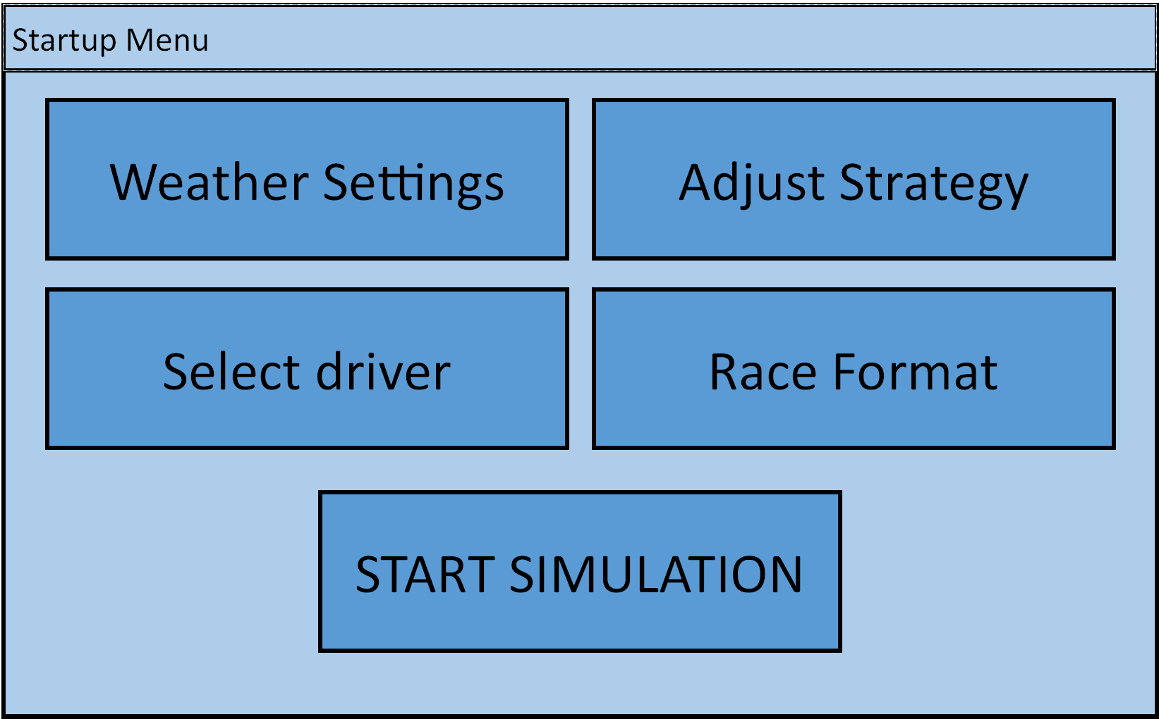
The initial startup menu will be the first thing the user sees when they run the program. It will give them 4 options for submenus and also a big button at the bottom which lets them start the simulation.
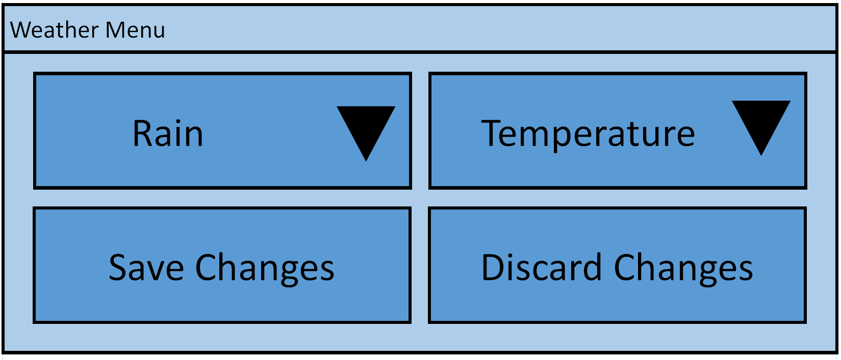
When the “Weather Settings” button is clicked on, this menu will open in a separate window. There is a dropdown menu for rain types and a slider for the temperature scale, and the user will have the choice to either save the changes they have made or discard them and close the window. An additional confirmation menu will pop up for these buttons.
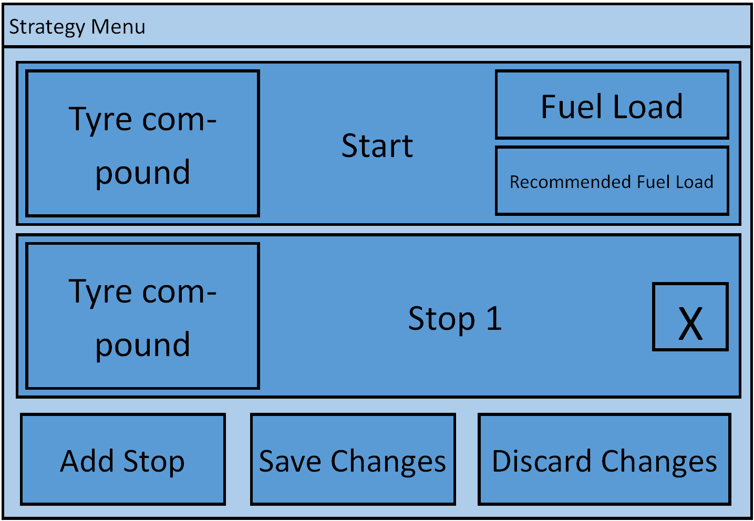
When the “Adjust Strategy” button is clicked, this menu will open. It will let the user adjust the starting tyre compound and fuel load, along with adding stops where they can change the old tyres for a fresh new set of tyres. Each stop will be stored as a class (diagram below). The user will also be able to remove stops if they want to. Similar to the weather menu, the user will have the option to save or discard changes. An additional confirmation menu will pop up for these buttons. When the user hovers over each option, a tooltip will be displayed telling them what fuel and tyre changes mean.
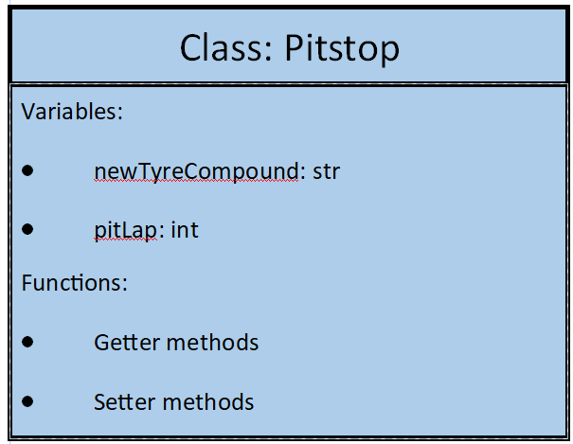
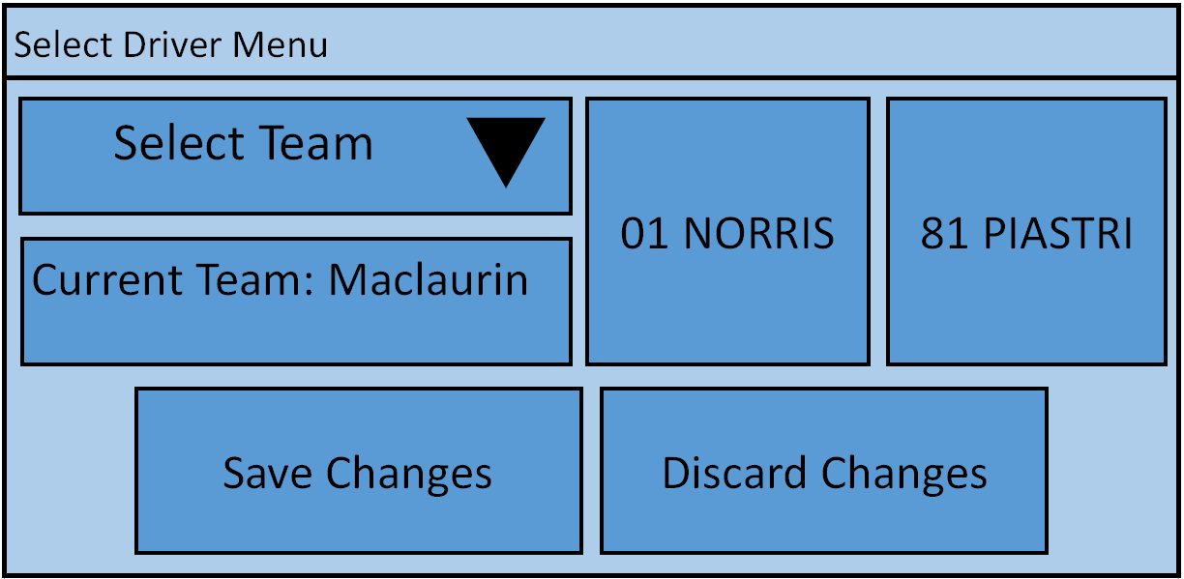
When the “Select driver” button is pressed, the select driver menu will open in a new window. It will give the player the option to select a team along with the driver that they want to manage. The driver selection will be done using a pair of buttons (1 for each driver) and the team selection will be done using a drop-down menu. Similar to the previous menus, there will be options to save or discard changes. Confirmation will be asked in a separate window before continuing.
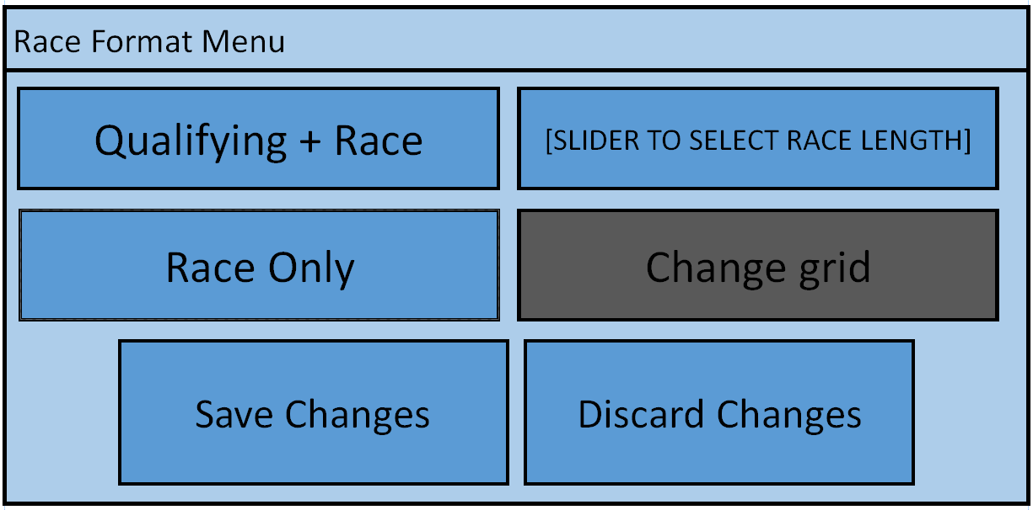
When the “Race Format” button is pressed, the race format menu will open in a new window. It will give the user the option to pick between only managing the race or doing qualifying too – qualifying is where the drivers have to set the fastest lap they can to start in a higher position on the grid. There is also a slider that the user can adjust to select the race length in laps. If the user opts to only do the race, the “Change grid” button will become available, and a new menu will open. This menu will allow the user to change where each driver starts and will benefit the less experienced users as they can skip doing the boring qualifying sessions and move straight onto racing. If the user opts to do qualifying, this option will be unavailable. Similar to the previous menus, there will be options to save or discard changes. Confirmation will be asked in a separate window before continuing.
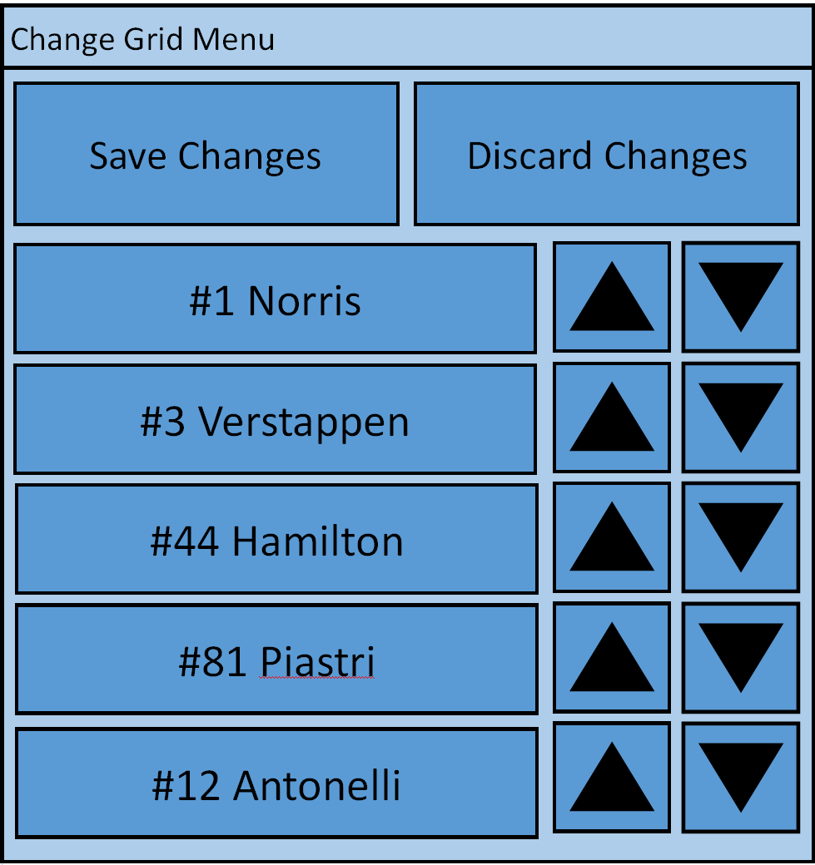
When the “Change grid” button is pressed, the change grid menu will appear in a separate window. It consists of save and discard changes buttons and a scrollable list box with elements inside. The elements will be a driver name and number along with 2 buttons to change their order.

Variables
Name | Data Type | Scope |  | Purpose

Confidence System

Next, I want to decompose my confidence system. It is a system that is meant to give the user a dynamic experience, so I want it to be able to intertwine with as many factors as possible.
The confidence system will be a value in the range of 0-100 and it will be stored in the car class. It should have a getter, setter and increment method alongside it for code readability.
A high driver confidence will lead to a lower chance of crashing, more frequent overtakes and an increase in pace. These are very valuable attributes so the user will be inclined to try and keep confidence as high as possible.
The factors that will positively affect the driver’s confidence are going to be when a successful overtake is completed and when the driver’s pace is above average for an extended period of time.
The factors that will negatively impact the driver’s confidence are going to be when they get overtaken by another driver, when weather conditions are poor (i.e. rain and high air temperatures) and when tyre wear is high (because the driver will find it hard to drive).
There are a lot more negative factors than positive ones. This will provide the user with a great challenge, but it is very doable: good pace is often up to the engineer to manage so their performance will greatly impact the confidence and therefore the race as a whole.

Generation of race data

For the first of my 3 main features, I will focus on generating race data. This will involve 2 subsections: car data and track data.
Car data is the main data that the engineer is focussed on; it is what they are looking at on their big monitors at the races. It involves numerous “data streams” including temperatures, pedal traces, spin, battery and fuel data. As previously stated in the analysis, this will be done completely in my program, making it a convenient solution for motorsport teams.
Temperatures, wear, wheelspin, fuel and driver inputs will be modelled with a simple equation that will update multiple times a second depending on where they are on the track. The battery will increase pace when deploying.
Track data will be a bit less in depth there is less to model. However, dynamic track temperatures and moisture along with a marbling system will create a fun and ever-changing experience for the user.
Surface temperature will slowly transfer heat to the tyres; high air temperature will also heat the tyres. Marbling will cause chunks of rubber to stick to the tyre and heat them up. Furthermore, rain will add unpredictability to the simulation, with bursts of rain randomly appearing throughout the race depending on the weather settings in the startup menu.
This race data will be stored in an SQL. This will allow the program to use the SELECT FROM WHERE syntax to quickly retrieve race data for analysis.

Graphical User Interface

The GUI is the second of my three main features. It is important that it is easy to use yet detailed enough for experienced users.
It should be able to show graphs in a different window so that multiple graphs can be open at once. On top of this, multiple data streams should be able to overlay over each other, as some data points complement each other.
A leaderboard should show where each driver is and their pace at a glance. It should be colour coded so that each team can find their driver at a glance.
A track map is also very useful for identifying where cars are, when they are fast and when they are slow. A circular map could be implemented where cars follow a circular track. It is very minimalistic and used when seeing the order of the cars is imperative. A map image version should also be available where cars are modelled as dots on an image. It is less clear what the race order is, but it is easier for the engineer to see where mistakes are being made.
A penalties menu should show if any drivers have outstanding time penalties or warnings.
A communication menu should allow the user to interact with the driver using simple buttons or inputs.
Key binds should be available to provide fast access to menus, benefitting experienced users.
Tooltips provide explanations of what each function does to the user, benefitting the less experienced users.

Communication system

The final part of my structure diagram is the communication system. It will be a simple UI with buttons and very simple inputs, rather than a voice to text system or otherwise.
The engineer should be able to designate areas to overtake. This could be to avoid marbling or to choose a part of the track where the driver is quicker to increase the chance of a successful overtake.
They should also be able to adjust pace to warm or cool the tyres, catch up to another car or for various other reasons.
They should be able to change the battery mode, with more deployment leading to a faster pace but less energy stores and vice versa.
Pitstops should also be an option. The driver should be able to choose which new tyres to put on, replace the front wing if it needs adjusting.

GUI Design
Next, I will design my GUI structure. I will generate it in accordance with my success criteria and my top-down structure diagram in order to satisfy stakeholders and create a project that flows seamlessly between each menu.

Startup Menu
The first part of my GUI will be the startup menu. It will have large buttons and sliders with clear instructions on what they do.

Software versions
Below is a list of all the software used in my project, including each tool’s purpose and the version installed at the time of setup.
Software | Purpose | Version
Tkinter | Graphical User Interfaces | Tcl/Tk 8.6.15
Microsoft Visual Studio Code | Integrated Development Environment (IDE) for developing my code and debugging using its built-in tools | 1.108.2
Matplotlib | Displaying graphs, specifically race data in graphs and charts | 3.10.8
Threading | Parallel processing for concurrency | (Built into Python 3.14.2)

References
(F-Man), h.-M. (2017). Assetto Corsa Footage.
(x4fab), I. J. (2024). Assetto Corsa's many settings through content manager addon.
Microsoft. (2021). Forza Horizon 5 Showcase Image.
Rein, I. h.-r. (2011). V15 Screenshots. Retrieved from Telemetry Tool: https://telemetrytool.com/v15_screens.php
ROSAVA. (n.d.). ᐉ What does camber mean? Caster | Answers from ROSAVA.
Srl, K. S. (2014, December 19). Assetto Corsa.
TmarTn2. (2021, 10 11). Forza Horizon 5 - The First Hour of Story Mode Gameplay. Retrieved from https://www.youtube.com/watch?v=qC9KSW8IhLQ

